**How to run the server**

1. Leave the folder structure as it is, this is important because some of the folders are generated and the application will not function as is if any of the folders are moved.
2. In SE2016,you will find the folder ‘tutorial’, there are all the steps to run the application

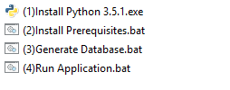

Run the files one by one (in order from top to bottom, wait until one is done to run the other, skip the python installation if you have python 3.4 or above, the .bat files will run in the console, prompting you with what is happening).

1. After Generate Database.bat has run a file named ‘Account Information.txt’ will appear in the folder, it should look like the photo below:

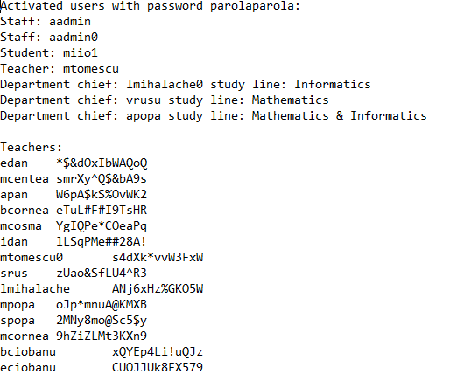

1. When you run ‘Run Server.bat’, after a few seconds you should be prompted with a console that looks like the photo below:

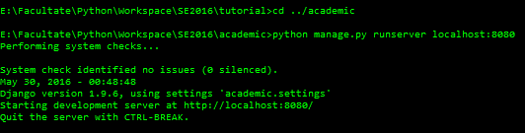

After that, you can open your browser and go to <http://localhost:8080> (in the address bar) and you will be prompted with our application’s login screen:

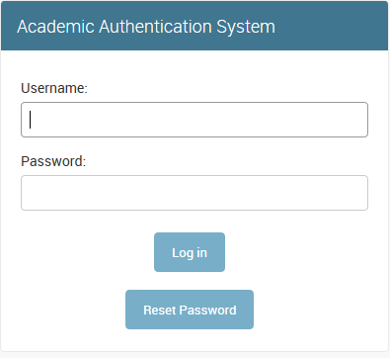

Use the activated accounts from ‘Account Information.txt’ with password ‘parolaparola’ to login into the system.

1. See user manual for further information on how to use the application.